ABSTARCT
The main objective of this project is to detect the faults and abnormalities occurring in underground cables using Arduino. The basic idea behind the working of this project is ohm’s law. At the feeder end, when a DC voltage is applied, based on the location of fault in the cable, the value of current also changes. So in case of short circuit faults like L-G or L-L fault the change in voltage value measured across the resistor is then fed to the in-built ADC of the Arduino. This value is processed by the Arduino and the fault is calculated in terms of distance from the base station. This value is sent to the LCD interface to the Arduino board and it displays exact location of the fault from the base station in kilometres for all three phases. This project is arranged with a set of resistors which represents the length of the cable. At every known kilometre fault switches are placed to induce faults manually. Finally the fault distance can be determined. The objective of this errand is to choose the partition of the failure of the underground connection in the base station using one kilometre of Arduino board. Underground connection structure is a run of the mill practice in various urban zones. Notwithstanding whether a mistake occurs for no good reason, around then the fix methodology related to this particular connection is inconvenient because of not knowing the unmistakable zone of connection dissatisfaction. The assignment uses the praiseworthy thought of the Ohms law, when a low voltage close to the completion of the power supply device is associated over a course of action resistor the present changes depending upon the zone of the Fault the connection. By virtue of a short out (grounded line), the voltage over the course of action resistors changes as requirements be, by then commitment to the ADC fabricates the Arduino board to make exact modernized data for the in kilometre. The endeavour is mounted with an impediment addressing the length of the connection in KM and making absconds is executed by a ton of switches in each acknowledged KM to check its precision. Dissatisfaction occurs at a given partition and the specific stage is appeared on a LCD screen related with the Arduino board.

CHAPTER 1
INTRODUCTION
The purpose of this project is to determine the distance from the base station's underground cable fault in kilometers. In this project we used a simple concept of ohm’s law .When a fault occurs in the system the distance located on liquid crystal display (LCD). Until the last decade, cables were designed to be placed above the head and, at present, there is no underground cable that is higher than the previous method. Adverse weather conditions such as storms, snow, torrential rains and pollution does not effect on underground lines, but when a fault occurs in underground lines it is difficult to locate the fault in underground cable. We will find the exact location of the fault. Now the world has become digitized so, the project is to detect exact location of the fault in digital form. Underground cabling system is a more common practice in many urban areas. Although the fault occurs for some reason, at that time, the repair process for this particular cable is difficult because of not knowing the exact location of the cable breakdown. In this paper we proposed a blame confinement show for the underground link lines with Arduino. The reason for this paper is to decide the separation from the base station's underground link blame in kilometers. In this task we utilized a basic idea of ohm's low .

When a blame happens in the framework the separation situated on fluid gem show (LCD).. Until the most recent decade, links were intended to be set over the head and, at present, there is no underground link that is higher than the past strategy. antagonistic climate conditions, for example, storms, snow, heavy rains and contamination doe no effect on underground lines But when a blame happens in underground lines it is hard to find the blame in underground link. We will locate the precise area of the blame. Presently the world has moved toward becoming digitized in this way, the venture is to identify definite area of the blame in computerized structure. Underground cabling framework is an increasingly regular practice in numerous urban zones. Despite the fact that the blame happens for reasons unknown, around then, the fix procedure for this specific link is troublesome in view of not knowing the accurate area of the link breakdown. Blame in link can be characterized in two gatherings. Tasks moved in Arduino UNO pack to perceive issues from the underground connections. Right when a fault occur in the underground connections, we can find faults through Arduino controller pack. LCD show which demonstrates the insufficiencies in Kilometer . In this endeavour we made faults physically. Connection has various sorts .Every connections has different deterrent which depends on the material used. The estimation of the hindrance is depends on the length of the connection. In here resistance is the principle occupation of the errand .If any deviation occur in the deterrent, the estimation of the voltage will be changed that particular point is called fault. We are find those imperfections. In this project we proposed a fault localization model for the underground cable lines with Arduino. The purpose of this paper is to determine the distance from the base station's underground cable fault in kilometres. In this project we used a simple concept of ohm’s low. When a fault occurs in the system the distance located on liquid crystal display (LCD).
Until the last decade, cables were designed to be placed above the head and, at present, there is no underground cable that is higher than the previous method. adverse weather conditions such as storms, snow, torrential rains and pollution does not affect on underground lines But when a fault occurs in underground lines it is difficult to locate the fault in underground cable. We will find the exact location of the fault. Now the world has become digitized so, the project is to detect exact location of the fault in digital form. Underground cabling system is a more common practice in many urban areas. Although the fault occurs for some reason, at that time, the repair process for this particular cable is difficult because of not knowing the exact location of the cable breakdown.
Fault in cable can be classified in two groups:
Open circuit fault:-In open circuit fault there is no current because there no conducting complete loop for current flowing that is I=0.in this fault supply voltage is equal to the output voltage. Open circuit fault is better than short circuit fault.
Short circuit fault:- In this fault output voltage is zero but current is same Further short circuit fault can be categorized in two types:
Symmetrical fault:- In this fault :equal lead current and equal phase shift.
Unsymmetrical fault: - In this fault magnitude of current is not equal & phase shifting is not equal by 120 degree.
Terminal method:- in this method used to detect the fault location in underground lines without any effort This method used to locate the type of circuit occurs; the voltage drop varies with the default length on the cable, as the current varies. A plurality of resistors is used to represent the cable and a DC voltage is supplied at one end and the defect detected by detecting the voltage variation the defect area to accelerate the tracking of the buried cable. Use of underground power cable is expanding due to safety considerations and enhanced reliability in the distribution systems in recent times. Due to safety reasons and high-power requirements in densely populated areas, use of underground cable has seen a sharp hike. The underground cable systems have the advantages of not getting affected by any adverse weather condition such as storm, snow, heavy rainfall as well as pollution. But it has its own drawback for immediate tracking of fault in the underground cable lines. Study of cable failures and development of accurate fault detection and location methods has been interesting research topics in the past and present. Fault tracking entails determination of the presence of a fault, while fault location detection includes the determination of the physical location of the fault. However, this fault detection and fault location detection technology for underground power distribution systems is still in developing stages. Before fixing any fault in cables, the fault has to be identified first. There are many ways to find the cable fault location. This paper deals with the method to locate faults and identify the phase line in damaged cables. A basic idea of fault location and phase identification in the pictorial view is undernoted. The objective of this project is to determine the distance of underground cable fault from base station in kilometers using an Arduino board. Generally, we use overhead lines. We can easily identify the faults but in rushed places or familiar cities we couldn’t use overhead lines. So, we are moving to underground cables. Underground cables used largely in urban area instead of overhead lines. We can’t easily identify the faults in the underground cables.
This project deals with arduino microcontroller, buzzer and LCD. This proposes greatly reduces the time and operates effectively. The underground cabling system is a common practice followed in many urban areas. Many time faults occur due to construction works and other reasons. At that time it is difficult to dig out cable due to not knowing the exact location of the cable fault. arduino microcontroller, buzzer and LCD. This proposes greatly reduces the time and operates effectively. The underground cabling system is a common practice followed in many urban areas. Many time faults occur due to construction works and other reasons. At that time, it is difficult to dig out cable due to not knowing the exact location of the cable fault.
ONLINE METHOD: This method utilizes and processes the sampled voltages and current to determine the fault points. Online methods for underground cable are less common than overhead lines.
OFFLINE METHOD: In this method special instrument is used to test out service of cable in the field. This offline method can be divided into two methods. They are tracer method and terminal method.
TRACER METHOD In this method fault point is detected by walking on the cable lines. Fault point is indicated from audible signal or electromagnetic signal. It is used to pinpoint fault location very accurately.
TERMINAL METHOD It is a technique used to detect fault location of cable from one or both ends without tracing. This method uses to locate general area of fault, to expedite tracing on buried cable.

The project is intended to detect the location of fault in underground cable lines from the base station to exact location in kilometers using an Arduino micro controller kit. In the urban areas, the electrical cable runs in undergrounds instead of overhead line s. Whenever the fault occurs in underground cable it is difficult to detect the exact location of the fault for process of repairing that particular cable. The proposed system finds the exact location of the fault. This system uses an Arduino microcontroller kit and a rectified power supply. Here the current sensing circuits made with a combination of resistors are interfaced to Arduino micro controller kit to help of the internal ADC device for providing digital data to the microcontroller representing the cable le ngth in kilometers. The fault creation is made by the set of switches. The relays are controlled by the relay driver. A 16x2 LCD display connected to the microcontroller to display the information. In case of short circuit the voltage across series resistors cha nges accordingly, which is then fed to an ADC to develop precise digital data to a programmed Arduino micro controller kit that fu rther displays exact fault location from base station in kilometers. Whenever a fault occurs in a cable the buzzer produce the alarm to alert and to take an immediate action by field workers. Programs uploaded in Arduino UNO kit to detect faults from the underground cables. When a faultoccur in the underground cables, we can find out faults through Arduino controller kit. LCD display which displays the faults in Kilometre. In this project we created faults manually. Cable has many types. Every cable has different resistance which depends upon the material used. The value of the resistance is depends upon the length of the cable. In here resistance is the leading role of the project. If any deviation occurs in the resistance, the value of the voltage will be changed that particular point is called FAULT. We are finding out those faults.
CHAPTER 2
LITRATURE SURVEY
“Arduino Based Underground Transmission Cable Fault Location System”, Roshani Shingrut, Dakshata Mokal, Shubham Shelar, Shekar Mhatre , IJERT, Vol.9 Issue 02, February 2020. The transmission line fault location requires intense human effort and resources. Typically this process is time consuming and while digging the cable there is a risk of damaging the insulation. This paper provides a simple and safe alternative by automating the process of fault detection and location. The project uses the simple concept of OHMs law where a low DC voltage is applied at the feeder end through a series resistor. The current would vary depending upon the length of fault of the cable in case there is a short circuit of LL or 3L or LG etc. The series resistor voltage droop changes accordingly which detects the exact location of the fault for process of repairing that particular cable. The proposed system finds the exact location of the fault. This system uses an Arduino micro controller kit and a rectified power supply. Here the current sensing circuits made with a combination of resistors are interfaced to Arduino micro controller kit to help of the internal ADC device for providing digital data to the microcontroller representing the cable length in kilometers. The fault creation is made by the set of switches. The relays are controlled by the relay driver. A 16x2 LCD display connected to the microcontroller to display the information. In case of short circuit, the voltage across series resistors changes accordingly, which is then fed to an ADC to develop precise digital data to a programmed Arduino micro controller kit that further displays exact fault location from base station in kilometers. The project in future can be implemented by using capacitor in an AC circuit to measure the impedance which can even locate the open circuited cable.
Abhishek Pandey, Nicolas H. Younan, they have Presented underground cable fault detection and identification through Fourier analysis[7]. The methods of impedance calculation by sending end voltage and differential voltage can be used for differentiating between the different types of cable defects from phase information. It needs study to find the best way of visualizing the results and especially the magnitude response. Power supply, 4 line display, arduino and resistance measurement circuit are needed in this circuit. Fault switches are used to induce faults manually in the kit. The fault switches have 2 positions-No fault position(NF) and fault position(F). About 12 fault switches are used which are arranged in three rows with each row having 4 switches. rows represent the 3 phases namely R,Y and B. Main component of the underground cable fault detection circuit is low value resistance measurement. By using a constant current source of 100mAmps it is constructed. It can measure ve low value resistance as the cables have around 0.01 Ohm/meter resistance. For 10 meter cable resistance becomes 0.1 Maximum cable length it can check up to 4 kilometers, This circuit can measure resistance up 50 Ohm. So int 4 sets of resistances are placed in series. These 4 sets of resistances represent the three Short circuit faults, Symmetrical and unsymmetrical faults can be determined by this method. This project uses three set of resistances in series R10-R11-R12-R12,R17-R16-R14R21,R20-R19 Each series resistor represents the resistance of the underground cable for a particular distance and so here 4kms.Value of each resistance is 10kΩ.
A. Ngaopitakkul, C. Pothisarn, M. Leelajindakrairerk The simulations were performed using ATP/EMTP, and by using DWT the analysis behavior of characteristics signals was Performed. Various case studies have been carried out including the single fault and simultaneous fault. 3. Yuan Liao, Ning Kang has presented fault location algorithms. This was without utilizing line parameters. By utilizing unsynchronized voltage and current measurements from both ends of line without requiring line parameters based on the distributed parameter line model. while line parameter estimates are sensitive to measurement errors the fault location estimate is not sensitive to measurement errors . Thus relatively precise measurements are required to obtain accurate line parameter estimates. The output from the transformer is given to the rectifier. A.C. into pulsating D.C is converted by it. The rectifier may be a half wave or a full wave rectifier. In this project, because of its merits like good stability a bridge rectifier is used. Four diodes connected to form a bridge in this circuit. A rectifier is an electrical device that converts alternating current (AC), which periodically reverses direction, to direct current (DC), which flows in only one direction. This is known as rectification. Rectifiers have many uses, but are often found serving as components of DC supplies and high-voltage direct current power transmission systems. Rectification may serve in roles other than to generate direct current for use as a source of power X. LCD To microcontroller 8051 Liquid crystal display are interfacing. Most commonly LCD used are 16*2 and 20*2 display. In 16*2 display means 16 represents column and 2 represents rows. LCD's are available to display arbitrary images (as in a general-purpose computer display) or fixed images with low information content, which can be displayed or hidden, such as preset words, digits, and 7-segment displays as in a digital clock. They use the same basic technology, except that arbitrary images are made up of a large number of small pixels where as other displays have larger elements.
S. Navaneethan, J. J. Soraghan, W. H. Siew, F.McPherson, P. F. Gale , presented an automatic fault location method using TDR. This method uses acquired data from an existing TDR instrument. It enables user of TDR equipment to locate ULVDN cable faults without user interpretation. Arduino is an open platform used for building electronics projects. Arduino consists of a physical programmable circuit board (often referred to as a microcontroller) and a piece of software, or IDE (Integrated Development Environment) that runs on your computer, it is used to write and upload computer code to the physical board. The Arduino platform has become popular with people just starting out with electronics, and for good reasons. The Arduino does not need a separate piece of hardware unlike most previous programmable circuit boards,(called a programmer) in order to load new code onto the board – you can simply use a USB cable. Additionally, the Arduino IDE uses a simplified version of C++, making it easier to learn to program. Finally, Arduino provides a standard form factor that breaks out the functions of the micro-controller into a more accessible package Relay is sensing device which senses the fault and sends a trip signal to circuit breaker to isolate the faulty section. A relay is an automatic device. Because of which an electrical circuit is indirectly controlled and is governed by change in the same or another electrical circuit. There are many types of relay Numerical relay, Static relay and electromagnetic relay. Relay are housed in panel in the control room. Here three mini power relay are used each for one of the three phases.The relays periodically scan the three phases and then the signal is send to the arduino controller. The rating of each of the relays is about 12V5 Volts 1-Channel relay module is an interface board that is compatible with Arduino.
H. Shateri, S. Jamali Et Al., Proposed An impedance based fault location method for three phase faults and phase to phase. This method utilized the measured impedance by distance relay and the super imposed current factor to discriminate the fault location. This method is sensitive to the measured super imposed current factor and impedance accuracy. This includes aesthetics, higher public acceptance, and perceived benefits of protection against electromagnetic field radiation (which is still present in underground lines), fewer interruptions, and lower maintenance costs. Failure rates of overhead lines and underground cables vary widely, but typically underground cable outage rates are about half of their equivalent overhead line types. Potentially far fewer momentary interruptions occur from lightning, animals and tree branches falling on wires which de-energize a circuit and then re- energize it a moment later. Primary benefits most often cited can be divided into four areas: Potentially-Reduced Maintenance and Operating Costs: Lower storm restoration cost. Improved Reliability: Increased reliability during severe weather(wind- related storm damage will be greatly reduced for an underground system, and areas not subjected to flooding and storm surges experience minimal damage and interruption of electric service. Less damage during severe weather Far fewer momentary interruptions Improved utility relations regarding tree trimming Improved Public Safety: Fewer motor vehicle accidents Reduced live-wire contact injuries Fewer Fires Improved Property Values: Improved aesthetics (removal of unsightly poles and wires, enhanced tree canopies). Fewer structures impacting sidewalks. In this project detect only the location of short circuit fault in underground cable line, and also detect the location of open circuit fault, to detect the open circuit fault capacitor is used in ac circuit which measure the change in impedance & calculate the distance of fault. For future research, proceed with similar neural networks structure for fault section and fault location estimation. animated components and microprocessor models to facilitate co-simulation of complete microcontroller based designs. This is very useful and user friendly to handle the components. The version used for project design is Proteus Professional 7.0. Proteus Professional Software for automated design of electronic circuits.

K.K. Kuan, Prof. K. Warwick, “Real-time expert system for fault location on high voltage underground distribution cables”,We uploaded the program in the kit. Program was written and if any fault occurs in the cable, immediately it will open the relay terminal and disconnect that faulty line only. Rest of the other lines operates normally. Arduino is the advanced version of embedded system. These Arduino has ample types but we selected Arduino UNO. It easily adapts to other devices using serial port. Relay is nothing but an electrical device that acts as a switch; if any fault occurs in the line it will disconnect the line using relay. The connector of the relay moves from normally closed conduct to normally open conduct. we can easily find the fault and disconnect the faulty line. Display unit is connected to the Arduino kit which is used to display where the fault occurs. Once faults occur in the cable, the display unit displays the exact fault location and also displays which phase is affected in the cable and how long it’s affected and buzzer system is used to create an alerting signal. Buzzer systems create an alerting sound signal, once the fault occurs in the underground cable.

CHAPTER 3
OBJECTIVES

Underground accuse discoverer oversees finding of exact accuse zone from the base station itself. Connections have some resistance. We are essentially focusing that hindrance. Resistance can change with respect to the length of the connection. In case the length of the connection is augmentation, the estimation of the resistance will similarly increase. If any deviation occurs in the impediment regard, we will call that is accuse point and finding that spot through arduino advancement. That accuse point is addresses the standard of detachment (kilometre) from the base station. This regard appeared by grandstand unit. Transformer is an electrical device that trades electrical imperativeness between in any event two circuits through electromagnet semiconduction. Generally, transformers are used to addition or decreasing the voltages of trading stream in electric power applications.

- Considering the Arduino as the Major Microcontroller for this Project, and Esp8266 or Esp32 as the IOT data Transfer to blynk Cloud or other Cloud.
- Considering the Three cable connectivity with Resistors and switch along with Relay, where we simulate the cable fault by using the switch.
- The data Stored in Arduino during switching process is transferred to cloud by IOT using mobile hot spot.
- Adapter or 12v stepdown Transformer used as a Basic Power Supply to the system of Uno and other Components along with Relay buzzer and sensor.
- Later the live notification and detection can be achieved by using IOT Blynk Cloud or other Cloud Applications.

CHAPTER 4
METHODOLOGY
BLOCK DIAGRAM:
LCD

ARDUINO
UNO
RELAY 1
CABLE 1
RELAY 3
CABLE 3

ESP8266
NODEMCU
RELAY 2
CABLE 2

POWER SUPPLY

BLYNK 2.0
OR ANY OTHER CLOUD

LED
BUZZER

FLOW CHART:
Engine Start
(12v Motor Run)

R1=R2=R3=0
RELAY1=No alert
R1=R2=R3=0
RELAY3=No alert

No Alert to Blynk
And Data to Cloud

R1=R2=R3=0
RELAY2=No alert

IF R1=1, R2=R3=0
IF R2=1, R1=R3=0
IF R3=1, R1=R2=0
RELAY1=Alert

IF R1=1, R2=R3=0
IF R2=1, R1=R3=0
IF R3=1, R1=R2=0
RELAY1=Alert

IF R1=1, R2=R3=0
IF R2=1, R1=R3=0
IF R3=1, R1=R2=0
RELAY1=Alert

Buzzer & Red LED on

Alert to Blynk
And Data to Cloud

A short circuit can be defined as an abnormal connection of very low impedance between two points of different potential, whether made intentionally or accidentally. These are the serious and most common kind of faults, resulting in the flow of abnormal high currents through the equipment or transmission lines. If these faults are allowed to persist even for a short period, it leads to the extensive damage to the equipment. Short circuit faults are also called as shunt faults. These faults are caused due to the insulation failure between phase conductors or between earth and phase conductors or both. The various possible short circuit fault conditions include three phase to earth, phase to phase, single phase to earth, two phase to earth and phase to phase. In single line to ground fault, fault occurs between any one of the three lines and the ground. In double line to ground fault, fault occurs between any two of the three lines and the ground. In line to line fault, fault occurs between any two lines. When fault occurs there is an abrupt change in voltage. This change in voltage may cause serious damages to the system if not corrected in time. So immediate step of fault correction is isolation of the faulty part from the rest of the system.
The transmission line fault location requires intense human effort and resources. Typically this process is time consuming and while digging the cable there is a risk of damaging the insulation. This paper provides a simple and safe alternative by automating the process of fault detection and location. The project uses the simple concept of OHMs law where a low DC voltage is applied at the feeder end through a series resistor. The current would vary depending upon the length of fault of the cable in case there is a short circuit of LL or 3L or LG etc. The series resistor voltage droop changes accordingly which detects the exact location of the fault for process of repairing that particular cable. The proposed system finds the exact location of the fault. This system uses an Arduino micro controller kit and a rectified power supply. Here the current sensing circuits made with a combination of resistors are interfaced to Arduino micro controller kit to help of the internal ADC device for providing digital data to the microcontroller representing the cable length in kilometers. The fault creation is made by the set of switches. The relays are controlled by the relay driver. A 16x2 LCD display connected to the microcontroller to display the information. In case of short circuit, the voltage across series resistors changes accordingly, which is then fed to an ADC to develop precise digital data to a programmed Arduino micro controller kit that further displays exact fault location from base station in kilometers. The project in future can be implemented by using capacitor in an AC circuit to measure the impedance which can even locate the open circuited cable.

HARDWARE REQUIREMENTS
ARDUINO UNO:
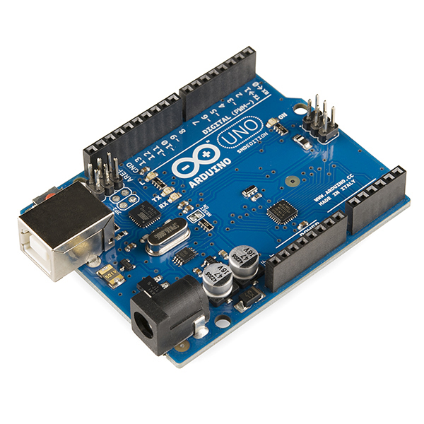
Arduino Uno is a microcontroller board based on the ATmega328P (datasheet). It has 14 digital input/output pins (of which 6 can be used as PWM outputs), 6 analog inputs, a 16 MHz ceramic resonator (CSTCE16M0V53-R0), a USB connection, a power jack, an ICSP header and a reset button. It contains everything needed to support the microcontroller; simply connect it to a computer with a USB cable or power it with a AC-to-DC adapter or battery to get started.. You can tinker with your Uno without worrying too much about doing something wrong, worst case scenario you can replace the chip for a few dollars and start over again."Uno" means one in Italian and was chosen to mark the release of Arduino Software (IDE) 1.0. The Uno board and version 1.0 of Arduino Software (IDE) were the reference versions of Arduino, now evolved to newer releases. The Uno board is the first in a series of USB Arduino boards, and the reference model for the Arduino platform; for an extensive list of current, past or outdated boards see the Arduino index of boards.
SPECIFICATIONS
- Microcontroller Atmega328p
- Operating Voltage 5v
- Input Voltage (Recommended) 7-12v
- Input Voltage (Limit) 6-20v
- Digital I/O Pins 14 (Of Which 6 Provide Pwm Output)
- Pwm Digital I/O Pins 6
- Analog Input Pins 6
- Dc Current Per I/O Pin 20 Ma
- Dc Current For 3.3v Pin 50 Ma
- Flash Memory 32 Kb (Atmega328p) Of Which 0.5 Kb Used By Bootloader
- Sram 2 Kb (Atmega328p)
- Eeprom 1 Kb (Atmega328p)
- Clock Speed 16 Mhz
- Led_Builtin 13
- Length 68.6 Mm
- Width 53.4 Mm
- Weight 25 G

BUZZER:
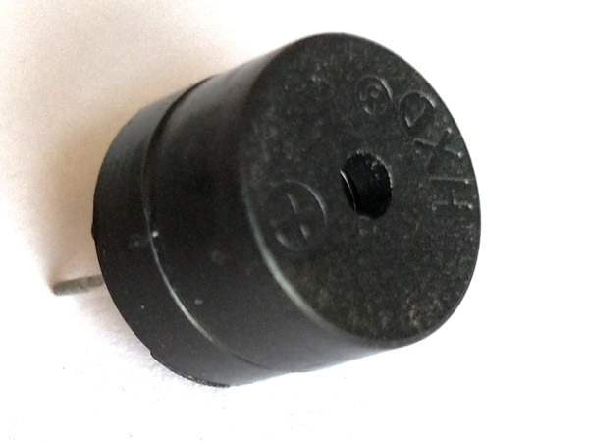
Buzzer Features and Specifications
• Rated Voltage: 6V DC
• Operating Voltage: 4-8V DC
• Rated current: <30mA
• Sound Type: Continuous Beep
• Resonant Frequency: ~2300 Hz
• Small and neat sealed package
• Breadboard and Perf board friendly

Equivalents for Passive Buzzer
Piezo Electric buzzer, Speaker, Active Passive Buzzer with Module
LED:
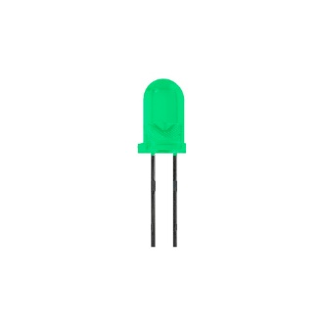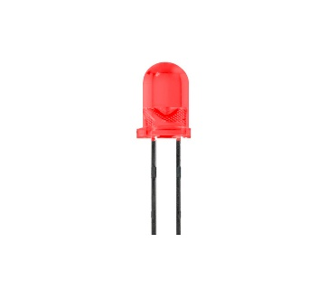
- Long Life: LEDs can last over 100,000 hours (10+ years) if used at rated specifications
- No annoying flicker like from fluorescent lamps
- LEDs are impervious to heat, cold, shock and vibration
- LEDs do not contain breakable glass
- Solid-State, shock and vibration resistant
- Extremely fast turn On/Off times
- Low power consumption puts less load on the electrical systems increasing battery life
POWER SUPPLY MODULE:
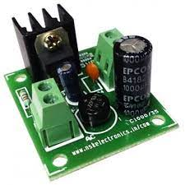
Specification
- Usage/Application Industrial
- Supply Voltage 5 V
- Output Voltages +1.8V, + 3.3V, +5V
- Maximum Load 0.75 Amps
- Input Efficiency 72 %
- Input Frequency Range 47 to 63 Hz
- Minimum Order Quantity 1 Piece

Description
  - Features
  - Input Voltage AC 0-12
  - Output Voltages: +1.8V, + 3.3V, +5V, +12V DC
  - Inputs and output connected to Terminal Blocks
  - Maximum Load 0.75amps

12V STEPDOWN TRANSFORMER:
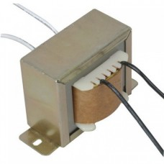
0-12 500mA Step Down Transformer is a general purpose chassis mounting mains transformer. Transformer has 230V primary winding and non-centre tapped secondary winding. The transformer has flying coloured insulated connecting leads ( Approx. 100 mm long ). The Transformer act as step down transformer reducing AC - 230V to AC - 12V.The Transformer gives outputs of 12V and 0V. The Transformer's construction is written below with details of Solid Core and Winding.
The transformer is a static electrical device that transfers energy by inductive coupling between its winding circuits. A varying current in the primary winding creates a varying magnetic flux in the transformer's core and thus a varying magnetic flux through the secondary winding. This varying magnetic flux induces a varying electromotive force (E.M.F) or voltage in the secondary winding. The transformer has cores made of high permeability silicon steel. The steel has a permeability many times that of free space and the core thus serves to greatly reduce the magnetizing current and confine the flux to a path which closely couples the winding.

Specifications of 0-12 500mA Step Down Transformer:-
- Input Voltage: 230V AC
- Output Voltage: 12V or 0V
- Output Current: 500mA
- Mounting: Vertical mount type
- Winding: Copper

Features of 0-12 500mA Step Down Transformer:-
- Soft Iron Core.
- 500mA Current Drain.
- 100% Copper Winding
Applications of 0-12 500mA Step Down Transformer:-
- DIY projects Requiring In-Application High current drain.
- On chassis AC/AC converter.
- Designing a battery Charger.

RESISTOR:
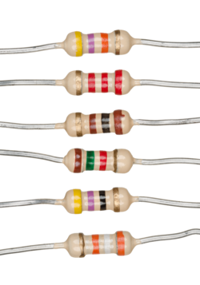
A resistor is a passive two-terminal electrical component that implements electrical resistance as a circuit element. In electronic circuits, resistors are used to reduce current flow, adjust signal levels, to divide voltages, bias active elements, and terminate transmission lines, among other uses. High-power resistors that can dissipate many watts of electrical power as heat may be used as part of motor controls, in power distribution systems, or as test loads for generators. Fixed resistors have resistances that only change slightly with temperature, time or operating voltage. Variable resistors can be used to adjust circuit elements (such as a volume control or a lamp dimmer), or as sensing devices for heat, light, humidity, force, or chemical activity.
Resistors are common elements of electrical networks and electronic circuits and are ubiquitous in electronic equipment. Practical resistors as discrete components can be composed of various compounds and forms. Resistors are also implemented within integrated circuits. The electrical function of a resistor is specified by its resistance: common commercial resistors are manufactured over a range of more than nine orders of magnitude. The nominal value of the resistance falls within the manufacturing tolerance, indicated on the component.

SWITHES:
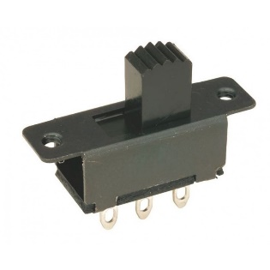
SPDT Slide Switch An electronic switch is an electronic component or device that can switch an electrical circuit, interrupting the current or diverting it from one conductor to another. Adding another pole to the SPDT creates a Single Pole, double-throw (SPDT) switch. Basically, two SPDT switches, which can control two separate circuits, but are always switched together by a single actuator. SPDTs should have six terminals. DPDT is a Single pole double throw switch; this is equivalent to two SPDT switches. It routes two separate circuits, connecting each of two inputs to one of two outputs. The position of the switch determines the number of ways in which each of the two contacts can be routed. This is a multipurpose STDP Slide Switch. It is medium-sided and perfect for mounting on boards and on enclosures, for which it comes with two holes on its body. Use this as an On/Off switch or just as a general-purpose switch. This switch can also be used to control the direction of a DC Motor. This Product Known as Switch Slide Mini SPDT, SPDT Slide Switch 3 Pin, Slide Switch – SPDT (3pin) On/On, 3 Pin Slide Switch, 3 Pin SPDT Slide Switch.
Applications:-
- These are very small SPDT slide switches
- There are holes for installation at each end of the switch
- They can be used for small power electronic projects
Specifications:-
- Material : Plastic and Metal
- Product Name : Slide Switch
- Contact Type : SPDT
- Voltage Max : 50V
- Current Max : 0.5A
- Position : 2
- Terminal Pins : 3
- Contact Resistance : 20M

RELAY:
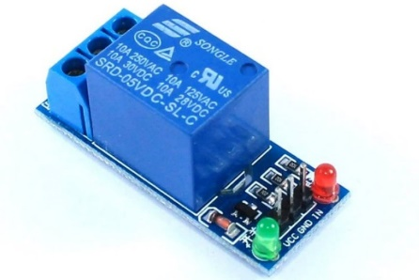
Relay is an electromechanical device that uses an electric current to open or close the contacts of a switch. The single-channel relay module is much more than just a plain relay, it comprises of components that make switching and connection easier and act as indicators to show if the module is powered and if the relay is active or not.
Single-Channel Relay Module Specifications
- Supply voltage – 3.75V to 6V
- Quiescent current: 2mA
- Current when the relay is active: ~70mA
- Relay maximum contact voltage – 250VAC or 30VDC
- Relay maximum current – 10A
12V STEPDOWN TRANSFORMER:

0-12 500mA Step Down Transformer is a general purpose chassis mounting mains transformer. Transformer has 230V primary winding and non-centre tapped secondary winding. The transformer has flying coloured insulated connecting leads ( Approx. 100 mm long ). The Transformer act as step down transformer reducing AC - 230V to AC - 12V.The Transformer gives outputs of 12V and 0V. The Transformer's construction is written below with details of Solid Core and Winding.
The transformer is a static electrical device that transfers energy by inductive coupling between its winding circuits. A varying current in the primary winding creates a varying magnetic flux in the transformer's core and thus a varying magnetic flux through the secondary winding. This varying magnetic flux induces a varying electromotive force (E.M.F) or voltage in the secondary winding. The transformer has cores made of high permeability silicon steel. The steel has a permeability many times that of free space and the core thus serves to greatly reduce the magnetizing current and confine the flux to a path which closely couples the winding.
Specifications of 0-12 500mA Step Down Transformer:-
- Input Voltage: 230V AC
- Output Voltage: 12V or 0V
- Output Current: 500mA
- Mounting: Vertical mount type
- Winding: Copper

Features of 0-12 500mA Step Down Transformer:-
- Soft Iron Core.
- 500mA Current Drain.
- 100% Copper Winding
Applications of 0-12 500mA Step Down Transformer:-
- DIY projects Requiring In-Application High current drain.
- On chassis AC/AC converter.
- Designing a battery Charger.
LCD:
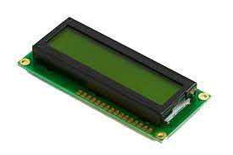
LCD stands for liquid crystal display it mostly used in different electronic projects and devices to display different values. LCD uses liquid crystals for the production of visible image. 16 x 2 liquid crystal display is a basic LCD module used in DIy electronic projects and circuits. In this LCD module, there are two rows every row consists of sixteen numbers.
With the two rows in this module, there are sixteen columns. The VA dimension of these modules are (66 x 16) millimetres and thickness is 13.2 millimetre. Its operating voltage is plus five or plus three volts. In today’s post we will have a look at working, applications, circuit, features, advantage and disadvantages. So let’s get started with Introduction to 16×2 LCD Module.

SOFTWARE REQUIREMENTS:

Arduino Integrated Development Environment (IDE) v1
Learn how the Arduino IDE v1 works, such as compiling & uploading sketches, file management, installing dependencies and much more.The Arduino Integrated Development Environment - or Arduino Software (IDE) - contains a text editor for writing code, a message area, a text console, a toolbar with buttons for common functions and a series of menus. It connects to the Arduino hardware to upload programs and communicate with them.
Writing Sketches
Programs written using Arduino Software (IDE) are called sketches. These sketches are written in the text editor and are saved with the file extension .ino. The editor has features for cutting/pasting and for searching/replacing text. The message area gives feedback while saving and exporting and also displays errors. The console displays text output by the Arduino Software (IDE), including complete error messages and other information. The bottom righthand corner of the window displays the configured board and serial port. The toolbar buttons allow you to verify and upload programs, create, open, and save sketches, and open the serial monitor.
Tools
Auto Format This formats your code nicely: i.e. indents it so that opening and closing curly braces line up, and that the statements inside curly braces are indented more.Archive Sketch Archives a copy of the current sketch in .zip format. The archive is placed in the same directory as the sketch.Fix Encoding & Reload Fixes possible discrepancies between the editor char map encoding and other operating systems char maps. Serial Monitor Opens the serial monitor window and initiates the exchange of data with any connected board on the currently selected Port. This usually resets the board, if the board supports Reset over serial port opening.

Board Select the board that you're using. See below for descriptions of the various boards. Port This menu contains all the serial devices (real or virtual) on your machine. It should automatically refresh every time you open the top-level tools menu. Programmer For selecting a hardware programmer when programming a board or chip and not using the onboard USB-serial connection. Normally you won't need this, but if you're burning a bootloader to a new microcontroller, you will use this.Burn Bootloader The items in this menu allow you to burn a bootloader onto the microcontroller on an Arduino board. This is not required for normal use of an Arduino board but is useful if you purchase a new ATmega microcontroller (which normally come without a bootloader). Ensure that you've selected the correct board from the Boards menu before burning the bootloader on the target board. This command also set the right fuses.

IOT BLYNK

Blynk was designed for the Internet of Things. It can control hardware remotely, it can display sensor data, it can store data, visualize it and do many other cool things.
There are three major components in the platform:
- Blynk App - allows to you create amazing interfaces for your projects using various widgets we provide.
- Blynk Server - responsible for all the communications between the smartphone and hardware. You can use our Blynk Cloud or run your private Blynk server locally. It’s open-source, could easily handle thousands of devices and can even be launched on a Raspberry Pi.
- Blynk Libraries - for all the popular hardware platforms - enable communication with the server and process all the incoming and outcoming commands.
Now imagine: every time you press a Button in the Blynk app, the message travels to the Blynk Cloud, where it magically finds its way to your hardware. It works the same in the opposite direction and everything happens in a blynk of an eye.
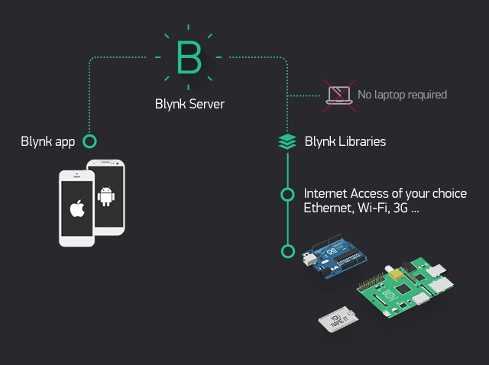

Features
- Similar API & UI for all supported hardware & devices
- Connection to the cloud using:
  - WiFi
  - Bluetooth and BLE
  - Ethernet
  - USB (Serial)
  - GSM
  - …
- Set of easy-to-use Widgets
- Direct pin manipulation with no code writing
- Easy to integrate and add new functionality using virtual pins
- History data monitoring via SuperChart widget
- Device-to-Device communication using Bridge Widget
- Sending emails, tweets, push notifications, etc.

CHAPTER 5
CONCLUSION
The hardware model of Underground Cable Fault Locator is implemented and favourable results were brought forward. This hardware model can locate the exact fault location in an underground cable. Further this project can be enhanced by using capacitor in an AC circuit to measure the impedance which can even locate the open circuited cable, unlike the short circuited fault only using resistors in DC circuit as followed in the above proposed project. It's an irksome errand to perceive the defects in underground connections. By using Arduino controller we can find cautious accuse region. At the point when issues occur in the connection, the feature unit demonstrates the distinct accuse territory that shows which stage is affected in the connection and to what degree it's impacted and ringer system is used to make a disturbing sign which is helpful to individuals. Chime system make a disturbing sound banner, once if the fault occur in the underground connection .

CHAPTER 6
REFRENCE
- “Arduino Based Underground Transmission Cable Fault Location System”, Roshani Shingrut, Dakshata Mokal, Shubham Shelar, Shekar Mhatre , IJERT, Vol.9 Issue 02, February 2020.
- In Abhishek Pandey, Nicolas H. Younan, they have Presented underground cable fault detection and identification through Fourier analysis[7]
  - Ngaopitakkul, C. Pothisarn, M. Leelajindakrairerk The simulations were performed using ATP/EMTP, and by using DWT
- S. Navaneethan, J. J. Soraghan, W. H. Siew, F.McPherson, P. F. Gale , presented an automatic fault location method using TDR
- H. Shateri, S. Jamali Et Al., Proposed An impedance based fault location method for three phase faults and phase to phase.

